**Nile University Differential equation 203i**

### Suspension bridge

MATH203i-Diffrential Equations Under the supervision of

Dr. Amira Mofreh

|  |  |
| --- | --- |
| **Ahmed Emad Osman** | **211001752** |
| **Rawan Hamdy Hussien** | **211000590** |
| **Ziad moataz Samy** | **211001556** |
| **Mohamed Ali Nassar** | **221000965** |
| **Abdelrahman Nasser Zaki Ahmed** | **221001430** |
| **Mohamed Hossam Hassan** | **211000405** |
| **Mohamed Ahmed Abd El Azim** | **211001926** |
| **Mohamed moamen sayed** | **211002194** |

##### Abstract

Suspension bridges are a specific kind of bridge in which the deck is suspended from vertical braces below suspension cables. Stiffening girders/trusses, main towers, main suspension cables, and anchorages for the cables at each end of the bridge are the primary elements of a suspension bridge system. While vertical suspenders support the weight of the deck and traffic, the main cables are suspended between towers and connected to the anchorage or the bridge itself. Suspension bridges are built using the cable erection method, which eliminates the need for false work. The main load-bearing member is the main cable, which is a tension member made of high-strength steel. Because the cable's full cross-section can effectively carry loads, buckling is not a concern, allowing for a longer span and lower deadweight.

Additionally, suspension bridges have an aesthetic advantage over other bridge types.

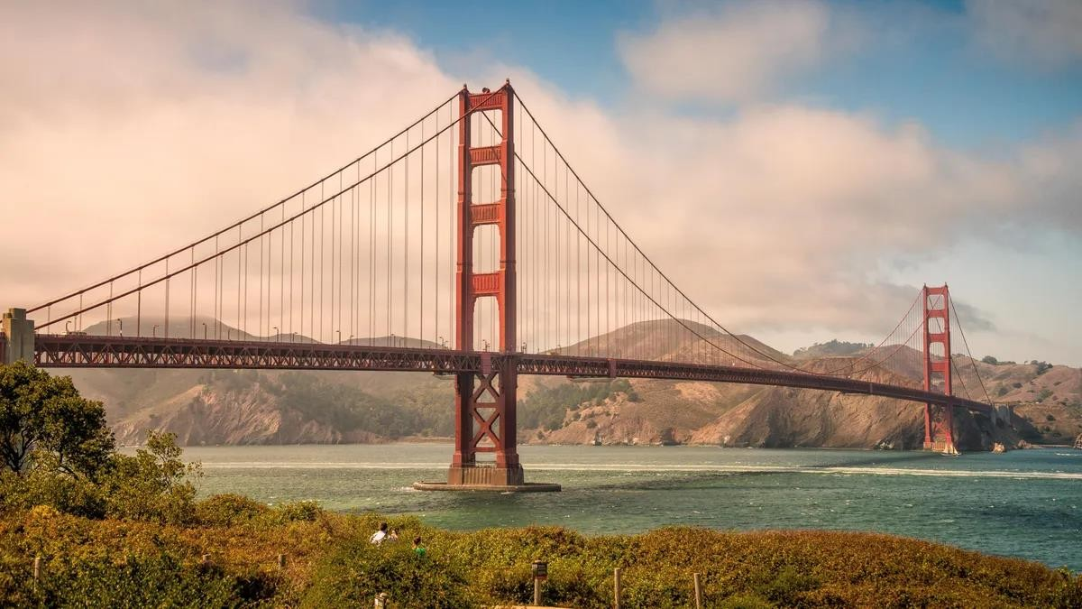

##### TABLE OF CONTENTS

ABSTRACT 1

TABLE OF CONTENTS 2

LIST OF FIGURES CAPTION 3

SECTION 1: Introduction 4

SECTION 2: Literature Review 5

SECTION 3: History of suspension bridge 12

SECTION 4: differential equations 13

SECTION 5: METHODOLOGY 14

SECTION 6: RESULTS 17

SECTION 7: CONCLUSION 18

REFERENCES 19

Keywords 21

Appendices 22

**LIST OF FIGURES CAPTION**

1. Figure (1): **Traditional Suspension Bridges**
2. Figure (2): **Cable-stayed Suspension Bridges**
3. Figure (3): **Tied Arch Bridges.**
4. Figure (4): **Extradosed Bridges**
5. Figure (5): **Self-anchored Suspension Bridges**
6. Figure (6): **Movable Suspension Bridges**

# SECTION 1: Introduction

Suspension bridges are impressive engineering feats, often serving as iconic symbols of their cities. The design and construction of these structures require careful consideration of various factors, including materials, stresses, and environmental impacts such as wind and earthquakes. The weight of the bridge deck in suspension bridges is supported by a cable system hung between two towers, with vertical suspenders connecting the deck to the main supporting cables. The primary load-bearing parts are the cable arcs that connect the towers to the anchorages at each end of the bridge. To prevent excessive movement, the deck must be heavy or stiff, or both, while the compression forces generated by the piers are transformed into tension forces in the cables. This report provides an overview of the design and construction of suspension bridges, with a particular focus on the use of differential equations in their analysis.

The differential equation will be used through Python code to apply it in a general suspended bridge.

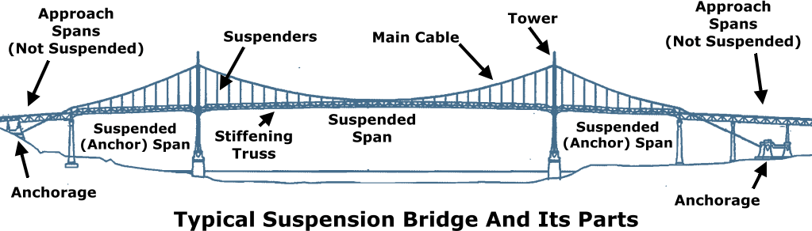

Suspension bridges have been used for centuries to span large distances and connect communities. Some of the earliest examples of suspension bridges were built by the Incas in the Andes Mountains, using natural fibers to create strong and flexible cables. There are several types of suspension bridges, including:

# Traditional Suspension Bridges:

Traditional suspension bridges are characterized by their iconic appearance with two tall towers that support the main cables, which in turn suspend the bridge deck. The cables themselves are made up of thousands of individual wires and are anchored into the ground on either side of the bridge.

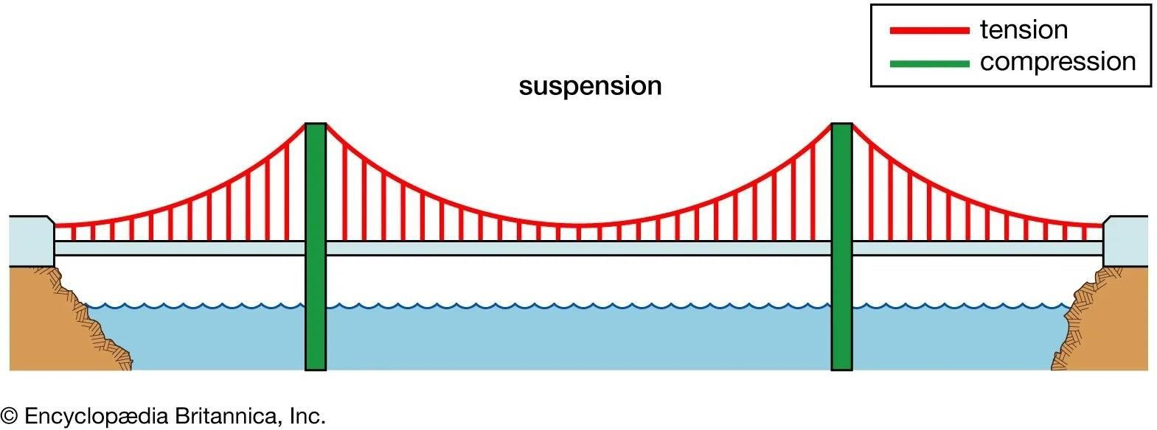

## (Fig.1)Traditional Suspension Bridges

Traditional suspension bridges have several advantages, such as their ability to span long distances while still allowing for a wide, unobstructed roadway. They also have a graceful, iconic appearance that has made them a popular choice for landmark structures. However, traditional suspension bridges also have some disadvantages. For example, they can be costly to construct due to the complex cable and tower systems required to support the bridge deck. Additionally, they are vulnerable to wind and seismic activity, which can cause the cables to sway and put stress on the

structure. Despite these challenges, traditional suspension bridges remain a popular choice for spanning large bodies of water and other long distances.

# Cable-stayed Suspension Bridges:

Cable-stayed suspension bridges feature one or more towers, which support multiple cables that run directly to the bridge deck. The cables are then anchored into the ground on either side of the bridge.

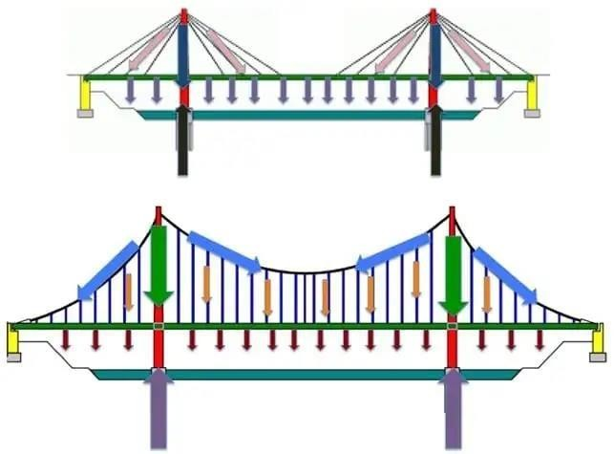

*(Fig.2) Cable-stayed Suspension Bridges*

Cable-stayed suspension bridges offer several advantages, such as their ability to span long distances with fewer towers than traditional suspension bridges, making them a more economical choice. They also offer more design flexibility, allowing for a wider range of aesthetic options.

However, cable-stayed suspension bridges also have some disadvantages. For example, they can be vulnerable to high winds due to their tall towers and large surface area. They also require a

complex cable and tower system that can be costly to construct and maintain. Despite these challenges, cable-stayed suspension bridges have become increasingly popular in recent years, thanks to their unique design and cost-saving benefits.

# Tied Arch Bridges:

Tied arch suspension bridges are characterized by a horizontal arch that is tied to the bridge deck and then supported by vertical suspenders that run up to the arch. The arch is then anchored into the ground on either side of the bridge.

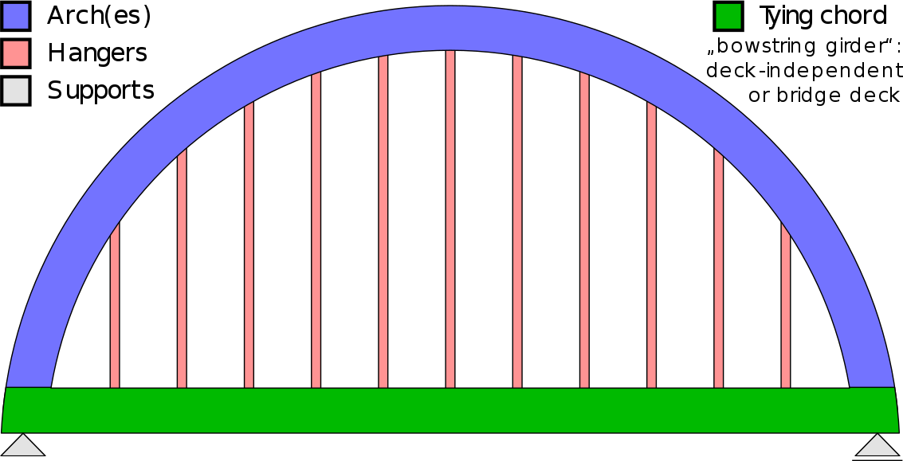

*(Fig.3) Tied Arch Bridges*

# Extradosed Bridges:

An extradosed bridge is a type of suspension bridge that combines elements of both traditional suspension bridges and cable-stayed bridges. The name "extradosed" refers to the fact that the bridge's cables are attached to the upper part of the bridge deck, or the extrados, instead of hanging below the deck as in a traditional suspension bridge. This design allows for shorter towers and fewer cables, making the bridge more economical to construct. Extradosed bridges typically span between 500 and 1,000 meters, and are commonly used for road and railway crossings.

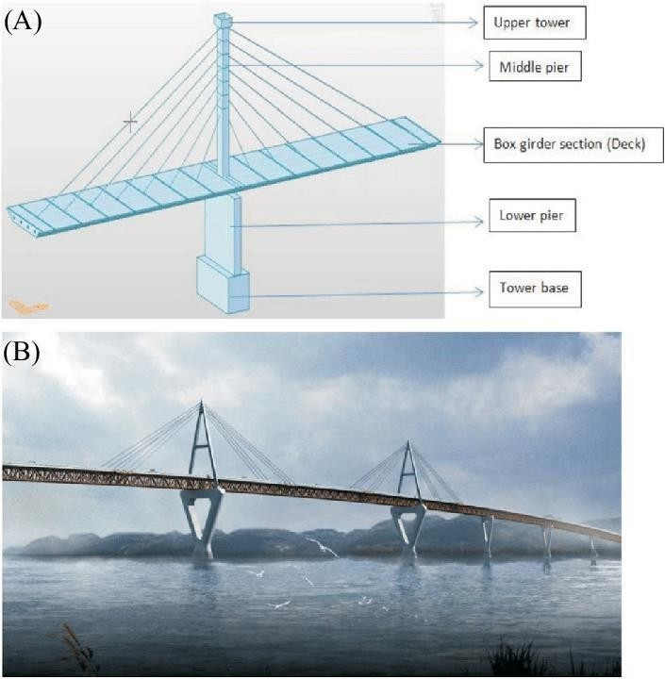

*(Fig.4) Extradosed Bridges*

Extradosed suspension bridges offer several advantages, such as their ability to span long distances with fewer cables and towers, resulting in a more economical and visually appealing structure.

They are also less vulnerable to wind and seismic activity compared to traditional suspension bridges. However, their shorter towers and unique cable arrangement can make them more challenging to construct and maintain, while requiring a strong and stable foundation, which can increase construction costs. Despite these challenges, extradosed suspension bridges remain a popular choice for their modern and striking design.

# Self-anchored Suspension Bridges:

Self-anchored suspension bridges are a type of suspension bridge that differs from traditional suspension bridges in that their cables are anchored directly to the bridge deck, rather than being anchored to the ground. This design allows for shorter towers and cables, which can help reduce construction costs and make the bridge more visually appealing. Self-anchored suspension bridges are often used for shorter spans, typically between 500 and 2,000 feet, and are well-suited for urban areas where space may be limited. However, they can be more challenging to construct and maintain due to the unique cable anchorage system, and they may not be as well-suited to withstanding high winds or other environmental stresses as traditional suspension bridges.

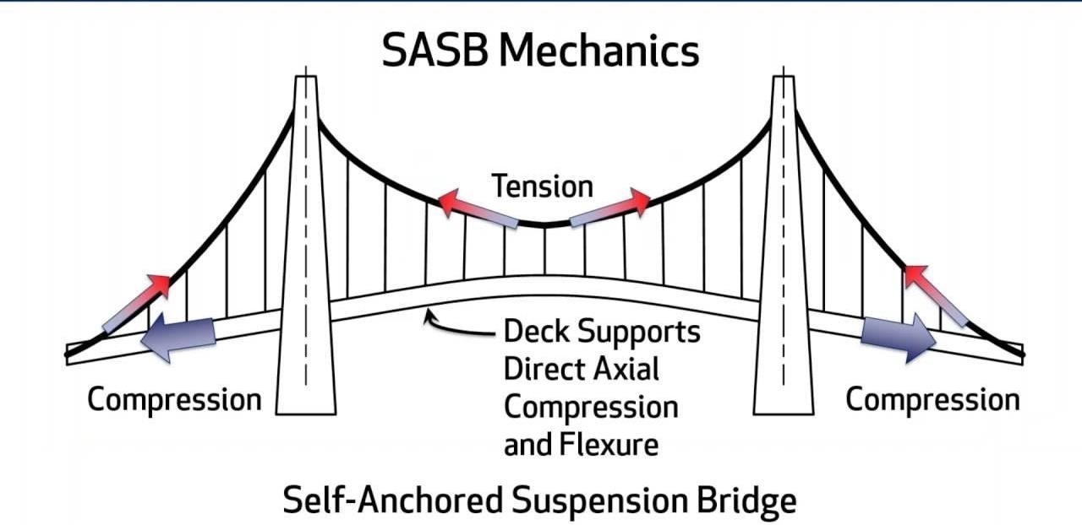

## (Fig.5) Self-anchored Suspension Bridges

Self-anchored suspension bridges offer several advantages, such as their ability to span long distances with a simpler and less expensive cable and tower system than traditional suspension bridges. They also have a unique, streamlined appearance that can be visually appealing. However, self-anchored suspension bridges also have some disadvantages. For example, they require a strong

and stable foundation to support the weight of the bridge, which can be challenging to achieve in some environments. Additionally, they can be more susceptible to wind and seismic activity than other types of suspension bridges, which can cause stress on the cables and other structural components. Despite these challenges, self-anchored suspension bridges remain a popular option for certain types of projects, particularly those with a focus on aesthetics and cost savings.

# Movable Suspension Bridges:

A movable suspension bridge is a type of suspension bridge that is designed to be lifted or swung out of the way to allow for the passage of boats or other watercraft. This type of suspension bridge is typically used in areas with heavy boat traffic where a fixed bridge would obstruct the waterway.

Movable suspension bridges are constructed with a special pivot or hinge mechanism that allows the entire bridge deck to be lifted or rotated upwards, usually by a hydraulic or mechanical system. This type of suspension bridge is typically more expensive and complex to construct and maintain than a fixed bridge, but it can be a necessary option in areas with significant water traffic.

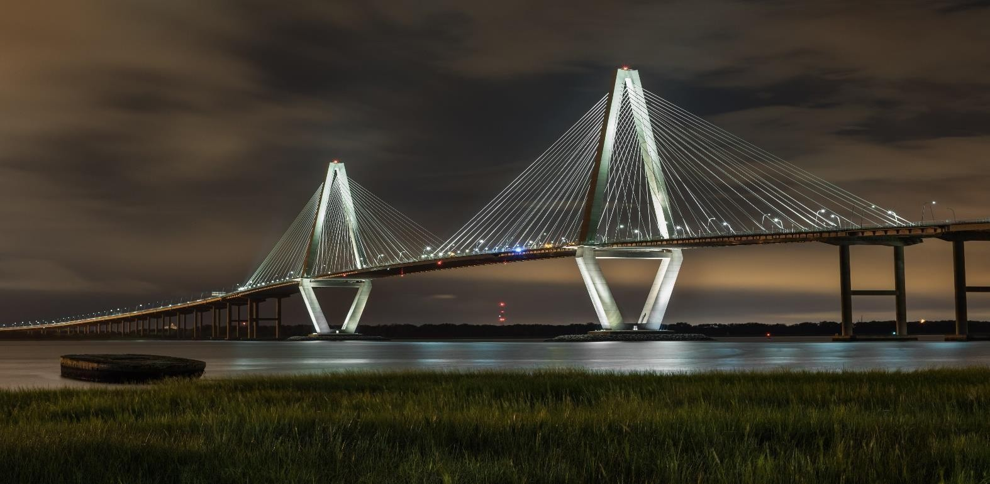

*(Fig.6) Movable Suspension Bridges*

Movable suspension bridges offer the advantage of allowing unobstructed waterway access, making them a necessary option in areas with significant water traffic. They can also be designed to provide greater clearance than fixed bridges, allowing larger boats to pass underneath. However, movable suspension bridges also have some disadvantages. They are typically more expensive to construct and maintain than fixed bridges, and their movable parts require regular inspection and maintenance to ensure proper functioning. Additionally, the movement of the bridge can cause traffic delays and disruptions. Despite these challenges, movable suspension bridges remain a critical infrastructure in many areas with significant water traffic, providing necessary access and supporting economic activity.

### SECTION 3: History of suspension bridge

The history of suspension bridges dates back to prehistoric times when vines were used to build simple structures. Over time, various materials were used to make suspension bridges stronger and more durable. Braided bamboo was used in India, followed by iron chains. Suspension bridges have been used for centuries to span large distances and connect communities. During the late eighteenth and early nineteenth centuries, British, French, American, and foreign engineers experienced severe difficulties with stability and strength against wind stresses and large loads.

However, advancements in technology and engineering have allowed for the development of safer and more reliable suspension bridges. The creation of the pneumatic caisson, which allowed for deep pier foundations, was an important innovation in modern suspension bridge construction. American engineers tried using a narrow rigid beam instead of a lattice truss in the 1930s to strengthen the roadway, but after the collapse of the Tacoma Narrows Bridge in 1940 due to aerodynamic forces, they reverted to using web struts. The web supports were later replaced by dynamically stable box girders. With the ability of modern steel alloys to support much greater distances, a number of record- breaking suspension bridges were built in Asia since the late 20th century. The Akashi Strait Bridge, which spans 1,991 meters (6,530 ft) across the Japanese islands of Honshu and Shikoku, is the longest. The Yangsigang Yangtze River Bridge, which spans 1,700 meters (5,577 ft) in Wuhan (Hubei), and the Nansha Bridge, which spans 1,688 meters (5,538 ft) in Dongguan, were completed in China in 2019 (Guangdong). Despite the challenges involved in designing and constructing suspension bridges, they continue to be an important type of infrastructure that plays a vital role in connecting communities and facilitating commerce.

##### SECTION 4: differential equations

1. Differential equation of the **cable-stayed** interval:

For the cable cable-stayed interval 𝑥 ∈ [x1, 𝑥2] 𝖴 [𝑥3, 𝑥4],the balance equation is:

T = C (C represents the constant), cos(𝛼 + 𝛽) − 𝑑

1 ′2 ,

𝑑𝑥 (𝑁𝑥 + 2 𝐸𝐴𝑏𝑣𝑏 ) = 0

where (𝛼 + 𝛽) is the angle between the stay cable and the x-axis positive direction after deformation.

1. Differential equation of the **suspension** interval:

For the suspension interval interval 𝑥 ∈ [𝑥3, 𝑥4],the balance equation is:

𝑑

𝑑𝑥

#### 𝑑

𝑑𝑥

#### [𝑇𝑐𝑜𝑠(𝜃 + 𝜑)] + 𝑠(𝑥) 𝑢𝑏 − 𝑢𝑐

√[ℎ(𝑥) + 𝑣𝑏 − 𝑣𝑐]2 + (𝑣𝑏 − 𝑢𝑐)2

#### [𝑇𝑐𝑜𝑠(𝜃 + 𝜑)] + 𝑠(𝑥) ℎ(𝑥) + 𝑣𝑏 − 𝑣𝑐

√[ℎ(𝑥) + 𝑣𝑏 − 𝑣𝑐]2 + (𝑣𝑏 − 𝑢𝑐)2

#### = 0,

= 0,

𝑑2

𝑑

#### 𝑑𝑥

(𝑁𝑥 +

#### 𝑑

1

#### 𝐸𝐴𝑏𝑣′2) − 𝑠

𝑏

2

(𝑥) 𝑢𝑏 − 𝑢𝑐

#### √[ℎ(𝑥) + 𝑣𝑏 − 𝑣𝑐]2 + (𝑣𝑏 − 𝑢𝑐)2

ℎ(𝑥) + 𝑣𝑏 − 𝑣𝑐

#### = 0,

𝑀𝑥 +

#### (𝑁𝑥𝑣′ ) + 𝑝 + 𝑞 − 𝑠(𝑥) = 0

#### 𝑑𝑥2

𝑑𝑥 𝑏

#### √[ℎ(𝑥) + 𝑣𝑏

− 𝑣𝑐

]2 + (𝑣𝑏

− 𝑢𝑐)2

Solving the differential equations for both the suspension interval and the cable-stayed interval is difficult. One approach is to use a family function that meets the boundary conditions and estimate an approximate solution using the concept of stationary potential energy. However, this is not the main focus of this study. Instead, this paper aims to demonstrate that using a continuum approach can provide a reasonably accurate description of how a self-anchored cable-stayed suspension bridge behaves under vertical load. To simplify the equations, some additional assumptions are made about the self-anchored suspension bridge.

##### SECTION 5: METHODOLOGY

There is no doubt that suspended bridges affected our engineering and scientific projects in an effective way which leads to having methods that right now we can understand it practically and theoretically and can be answer to many questions like the air spinning method , a suspension bridge that carries vertical loads through curved cables in tension which was an revolution in the math science equations .

The suspension bridge is built this way:

First This step involves identifying a suitable location for the bridge. Factors such as terrain, geological conditions, water depth, environmental impact, and potential traffic flow are taken into account during the site selection process. After this, Once the site is selected, a detailed survey is conducted to gather data on the site's topography, geological conditions, wind and weather patterns, water depth, and other relevant information. This data is used to design the bridge's preliminary structure and determine the necessary materials and components.

The next step is to build the foundation and anchorages that will support the bridge's weight and tension. This typically involves drilling deep into the ground to create sturdy concrete pillars or steel anchors that will anchor the suspension cables. After the foundation and anchorages are complete, the next step is to erect the towers that will support the main suspension cables. The cables aretypically made of high-tensile steel and are carefully calibrated to handle the bridge's weight and load.

They are anchored at each end of the bridge and looped over the towers. With the towers and main cables in place, the next step is to attach the decking that will support the road or pedestrian walkway. This is typically done using smaller cables known as "suspender cables," which are attached to the main cables at regular intervals and anchored to the bridge deck.

Once the decking is in place, the bridge's lighting and finishing touches are added. This includes installing lighting to illuminate the bridge at night, adding safety features such as guardrails and barriers,

and painting the bridge to protect it from the elements. Thefinal step involves rigorous testing and inspection of the bridge to ensure it is safe and structurally sound.This includes load testing, which involves driving heavy vehicles across the bridge to test its weight capacity, and regular inspections to check for signs of wear and tear.

### The differential equation of a general suspension bridge can be expressed as:

mx''(t) + cx'(t) + kx(t) = F(t)

m is the mass of the suspended roadway

x(t) is the vertical displacement of the roadway from its equilibrium position at time t c is the damping coefficient

k is the stiffness of the cables and roadway

F(t) is the external load acting on the bridge at time t.

We can solve this equation by a lot of method in differential equations such that integrating factors and others we will solve it by integrating factors first To use this , we should at the start find integrating factor, which be :

I(t) = e^(∫(c/m)dt) = e^(ct/2m)

Multiply all sides of this equation by integrating factor, and the result is : e^(ct/2m)mx''(t) + e^(ct/2m)cx'(t) + e^(ct/2m)kx(t) = e^(ct/2m)F(t)

Now, we can apply the product rule to the left-hand side of the equation: (e^(ct/2m)mx'(t))' + e^(ct/2m)(cx'(t) + kx(t)) = e^(ct/2m)F(t)

Integrating all sides for this equation with respect to t, the result will be : e^(ct/2m)mx'(t) + ∫(e^(ct/2m)(cx'(t) + kx(t)))dt = ∫(e^(ct/2m)F(t))dt + C where C is the constant of integration.

Simplifying the integrals on the left-hand side using the product rule and integrating by parts, we can obtain an expression for x(t):

x(t) = (1/k)e^(-ct/2m)∫(e^(ct/2m)F(t))dt + Ae^(-ct/2m) + Be^(ct/2m)

where A and B are integration constants that the system's initial conditions dictate.

This method is a powerful tool for solving linear second-order differential equations with constant

coefficients, such as the one governing the motion of a suspension bridge.

##### SECTION 6: RESULTS

Our implementation uses the fourth-order Runge-Kutta method to discretize the differential equation and approximate the displacement x(t) at discrete time intervals. The resulting displacement values are then presented graphically as a function of time to simulate the system's motion and visualize its behavior. The system's specific behavior is determined by the values of parameters such as m, c, k, A, and omega, as well as the initial conditions x0 and v0. For instance, a large damping coefficient c results in rapid energy dissipation and quick damping of the oscillations. Conversely, a large spring constant k produces stronger oscillations. The motion of the system is also influenced by the external force F(t). In this implementation, F(t) is a sinusoidal function of time, causing the system to exhibit periodic oscillations.

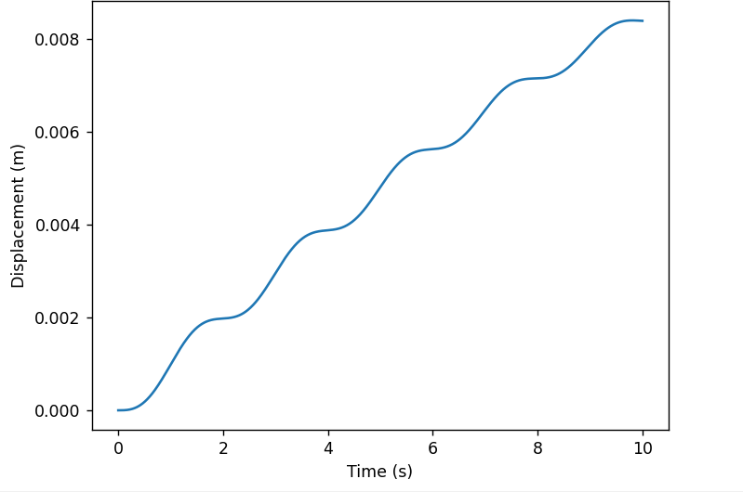

The output of this code is a plot of the displacement x(t) of the system over time. The plot provides a visual representation of how the displacement changes over time, depending on the specific values of the parameters and initial conditions specified in the code.

##### SECTION 7: CONCLUSION

Suspension bridges are an impressive feat of engineering that require careful consideration of various factors, including materials, stresses, and environmental impacts. They have been used for centuries to span large distances and connect communities. Suspension bridge technology has continued to evolve over the years, with engineers using increasingly advanced materials and techniques to build structures that are longer, stronger, and more resilient. However, there are still challenges that must be overcome in order to build safe and reliable structures. One of the biggest challenges is the issue of fatigue, which can cause the bridge to deteriorate over time. Despite these challenges, suspension bridges continue to be an important type of infrastructure that plays a vital role in connecting communities and facilitating commerce. The process for building a suspension bridge involves constructing the foundation and superstructure, followed by the towers or piers, primary supporting cables, and the bridge deck. The safety of suspension bridges is heavily reliant on the integrity of their primary cables, and the remaining tensile strength of these cables can be assessed through three-dimensional random field simulation methodology. As technology continues to advance, suspension bridge design and construction will continue to evolve as well, pushing the limits of what is possible in engineering and architecture.

##### REFERENCES

* 1-civiljungle.com. (n.d.). Suspension Bridge: Types, Parts, Advantages, Disadvantages. <https://civiljungle.com/suspension-bridge/>
* 2-Li, H., Li, M., Li, X., & Li, Z. (2022). Design and Analysis of a Suspension Bridge with a Novel Substructure Configuration. Journal of Advanced Transportation, 2022, 1- 18. <https://doi.org/10.1155/2022/1211345>
* 3-Encyclopaedia Britannica. (n.d.). Suspension bridge. In Britannica. <https://www.britannica.com/technology/suspension-bridge>
* 4-Chu, S. (2017). Analyzing the Static and Dynamic Behaviors of Self-Anchored Cable-Stayed Suspension Bridges Using a Continuum Approach. Retrieved from <https://scholarworks.lib.csusb.edu/cgi/viewcontent.cgi?article=3648&context=etd-project>
* 5-According to the article "Suspension bridge" on Britannica.com, "a suspension bridge is a type of bridge in which the deck (the load-bearing portion) is hung below suspension cables on vertical suspenders." (Source: <https://www.britannica.com/technology/suspension-bridge>)
* 6-IHI Corporation. (n.d.). Air spinning. Retrieved March 27, 2023, from [https://www.ihi.co.jp/iis/en/technology/airspining/index.html#:~:text=The%20cable%20ere](https://www.ihi.co.jp/iis/en/technology/airspining/index.html#%3A~%3Atext%3DThe%20cable%20erection%20of%20a%2CWire%20Strand%20(PPWS)%20method)

[ction%20of%20a,Wire%20Strand%20(PPWS)%20method](https://www.ihi.co.jp/iis/en/technology/airspining/index.html#%3A~%3Atext%3DThe%20cable%20erection%20of%20a%2CWire%20Strand%20(PPWS)%20method).

* 7-Edwards, J. (2021). Rethinking the Medieval Apocalypse in a Time of Pandemic.

Columbia University Academic Commons. <https://doi.org/10.7916/d8-fj2d-wz>

* 8- O'Nan, M. (2016, September 20). Outer space: Bridging the gap. Plus Magazine. [https://plus.maths.org/content/outer-space-bridging-](https://plus.maths.org/content/outer-space-bridging-gap#%3A~%3Atext%3DThe%20equation%20for%20the%20shape%2Cin%20the%20details%20for%20yourself)

[gap#:~:text=The%20equation%20for%20the%20shape,in%20the%20details%20for%20you](https://plus.maths.org/content/outer-space-bridging-gap#%3A~%3Atext%3DThe%20equation%20for%20the%20shape%2Cin%20the%20details%20for%20yourself)

[rself](https://plus.maths.org/content/outer-space-bridging-gap#%3A~%3Atext%3DThe%20equation%20for%20the%20shape%2Cin%20the%20details%20for%20yourself)).

* 9-Huang, Y., Zhang, Y., & Zhong, Y. (2010). Stability analysis of switched positive linear systems with time delay. Mathematical Problems in Engineering, 2010, Article 805195. <https://doi.org/10.1155/2010/805195>

### Keywords

* Differential equation
* Suspension bridge
* Cable-stayed bridge
* Displacement
* Separation method
* Numerical integration
* Damping coefficient
* External force
* Velocity
* Mass
* Earthquake load
* Tension
* Runge-Kutta method

##### Appendices

import numpy as np

import matplotlib.pyplot as plt

# Define the parameters of the model m = 2000 # mass of the cables (kg)

c = 50 # resistance of the cables to move (N*s/m) k = 20000 # spring constant (N/m)

# Define the initial conditions x0 = 1 # initial displacement (m) v0 = 0 # initial velocity (m/s)

# Define the time range t_start = 0 # start time (s) t_end = 5 # end time (s) t_step = 0.01 # time step (s) def model(t, x):

# Extract the state variables from x x1 = x[0] # displacement

x2 = x[1] # velocity

# Evaluate the right-hand side of the differential equations x1dot = x2

x2dot = (1/m)*(F(t) - c*x2 - k*x1)

# Return the derivative of the state variables xdot = [x1dot, x2dot]

return xdot

# Define the function that represents the external force

def F(t):

# In this example, we will assume that the external force is a simple # sinusoidal function of time, with amplitude A and frequency omega A = 200 # amplitude (N)

omega = 0.2 # frequency (1/s) return A*np.sin(omega*t)

def rk4(t, x, dt, model):

# Define the four Runge-Kutta coefficients k1 = dt * model(t, x)

k2 = dt * model(t + dt/2, x + k1/2) k3 = dt * model(t + dt/2, x + k2/2) k4 = dt * model(t + dt, x + k3)

# Update the state of the system

x += 1/6*(k1 + 2*k2 + 2*k3 + k4) return x

# Initialize the time and state variables t = t_start

x = [x0, v0]

# Initialize an empty list to store the results t_values = []

x_values = []

# Iterate over the time range while t < t_end:

# Append the current time and state to the results t_values.append(t)

x_values.append(x)

# Update the state of the system x = rk4(t, x, t_step, model)

# Update the time t += t_step

# Convert the results to NumPy arrays t_values = np.array(t_values) x_values = np.array(x_values)

# Plot the results plt.plot(t_values, x_values[:,0]) plt.xlabel('Time (s)') plt.ylabel('Displacement (m)') plt.show()